.Net Core Training Final Project Document

User logins page appear , user need to enter their username and password.

After entering the password, Used to have post method of API call “api/Users/authenticate ”

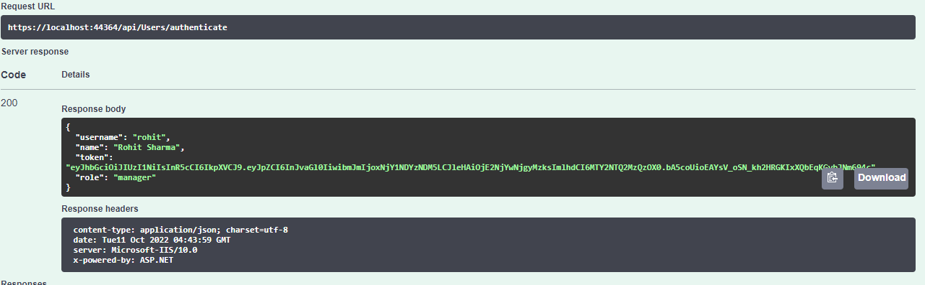

Home page:

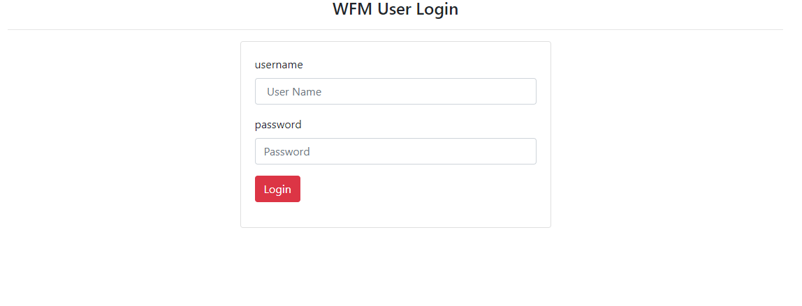

After user successfully authenticated, redirects them based on the role of manager and wfm-member:

UI screen for Manager: which calls the api with token got while login “api/Employees/GetEmployees ”

Which is a get method, if we doesn’t pass token leads to message unauthorized.

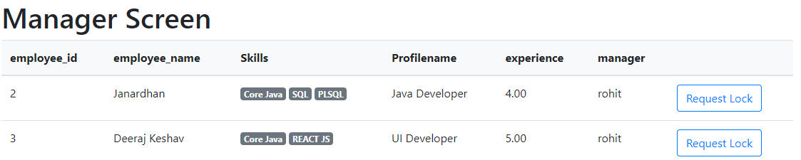

Api response:

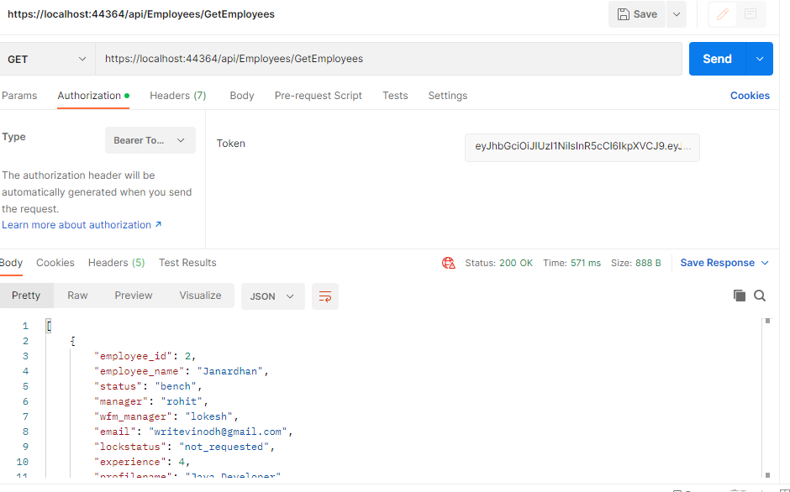

If the user Clicks on Request lock following screen will appear:

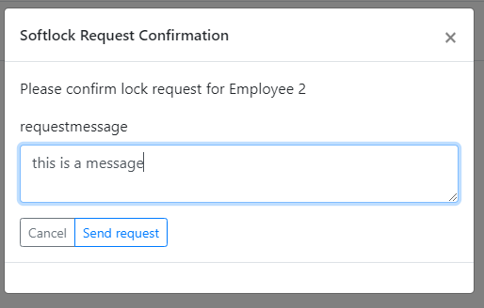

After Clicking the Send request it used to have call to post method of Api with token:

“/api/Softlocks/InsertSoftlocks”.

It will insert into softlock table and to update the it used call put method with token:

“/api/Employees/UpdateEmployees”.

Change lock status of employee table as request _waiting.

WFM-Member Screen:

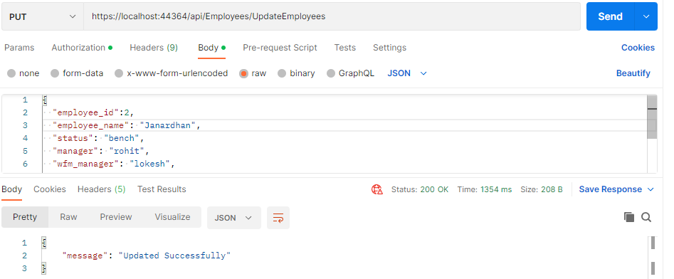

If the user role is wfm-member (UI screen):

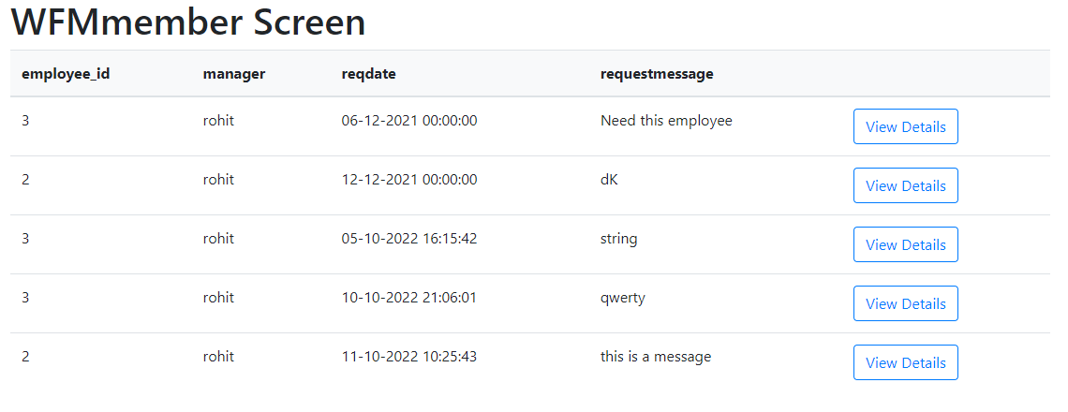

Used to api with token ”api/Softlocks/GetAllSoftlocks”. After clicking on view detailsused to popup screen and check the employee details and you can accept or reject that employee.

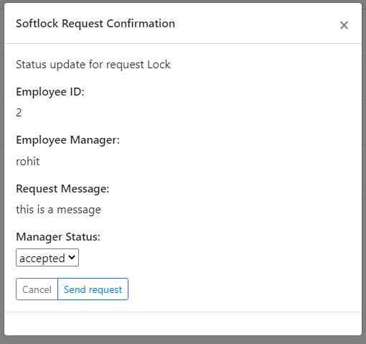

After clicking the sendrequest it used to call api ”/api/Softlocks/UpdateSoftlocks”.

To update the Softlock table to accepted /rejected status.

If the status is accepted, update the employee table of lock status as “locked”,

Else it update the employee table of lock status as “rejected”.

Api used for update Employee “api/Employees/UpdateEmployees”.